**Team Project 1**

Project 1B – Addition of Two Polynomials

**Bryce Thornton**

**Robert Blocker**

**October 23rd, 2022**

**Table of Contents**

1. System Design 2

2. UML Diagram 2

3. Test Cases 2

4. Team Member Contribution 2

5. Possible Improvements 2

# System Design

Our system implemented the use of a Linked List to store the user inputted polynomials. We used the List.h header file created by Professor Wang in the implementation of the project and also used the implementation of the doubly linked list node.. The doubly-linked list was used to sort the coefficients and polynomials of each term. As the structure of the doubly-linked list, there is a “prev” Node that holds the address of the previous Node in the list, then there are the two data elements that hold the coefficient and exponent of each parsed-term of the polynomial, and then there is a “next” Node which contains the address of the next Node in the list.

The create_term() function creates a Term object from a string that the user input into the console and returns the Term object which is the coefficient and exponent.

The create_list() function creates a doubly-linked list from the given polynomial string from the user. This function takes a string and returns the linked list containing the Terms from the user defined list.

Sort() takes the list from the create_list() function and sorts the polynomials in descending order (highest term order).

Add_polynomials() function was to take the sorted lists and add coefficients of the same exponent and push onto a final linked list and then output the linked list in the correct format.

# UML Diagram

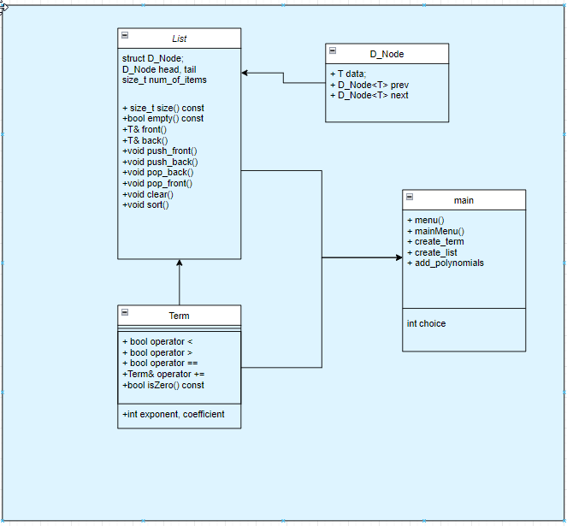

# Test Cases

For the first test, we want to add the following polynomials:

3x3+2x2+4x

2x3+4x2+10

Let’s put this into readable syntax for the console and enter the polynomials separately:

3x^3+2x^2+4x

2x^3+4x^2+10

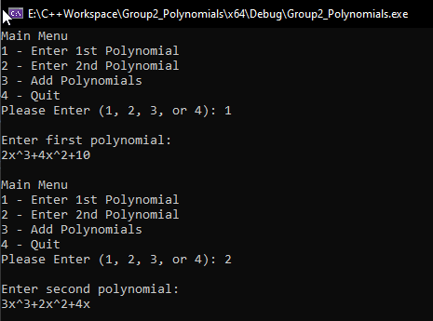

Once we type r, we expect that the polynomials would be sorted and added together:

3x^3+2x^2+4x + 2x^3+4x^2+10 → 3x^3 + 2x^3 + 2x^2 + 4x^2 + 4x + 10

We expect the program to output the added polynomial like so:

5x^3 + 6x^2 + 4x + 10

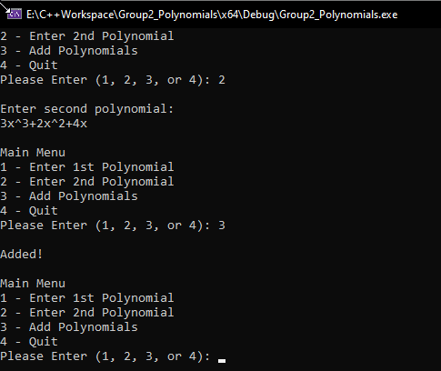

Unfortunately, the program does not output the added polynomial.

# Team Member Contribution

Bryce Thornton – Bryce worked on a large portion of the development of the code for the project. Through logic and testing, Bryce helped make sure his code functioned properly. Bryce was responsible for code in the Term class and with the sort() function to sort the lists of polynomials.

Robert Blocker – Robert was responsible for code development and documentation of the system. Robert was responsible for the add_polynomials() function and to output the final polynomial to the console. Robert documented the project and made sure the group’s logic flowed into the document.

# Possible Improvements

* The polynomials should have been added, however the function was incomplete and did not run properly. Thus, the function of the program to add the polynomials was not completed and the polynomials were only sorted in the linked lists. Robert Blocker was tasked to complete the function and was unable to complete the function.
* The design of the system could be improved by trying to develop a system that was more conscious of the time complexities.